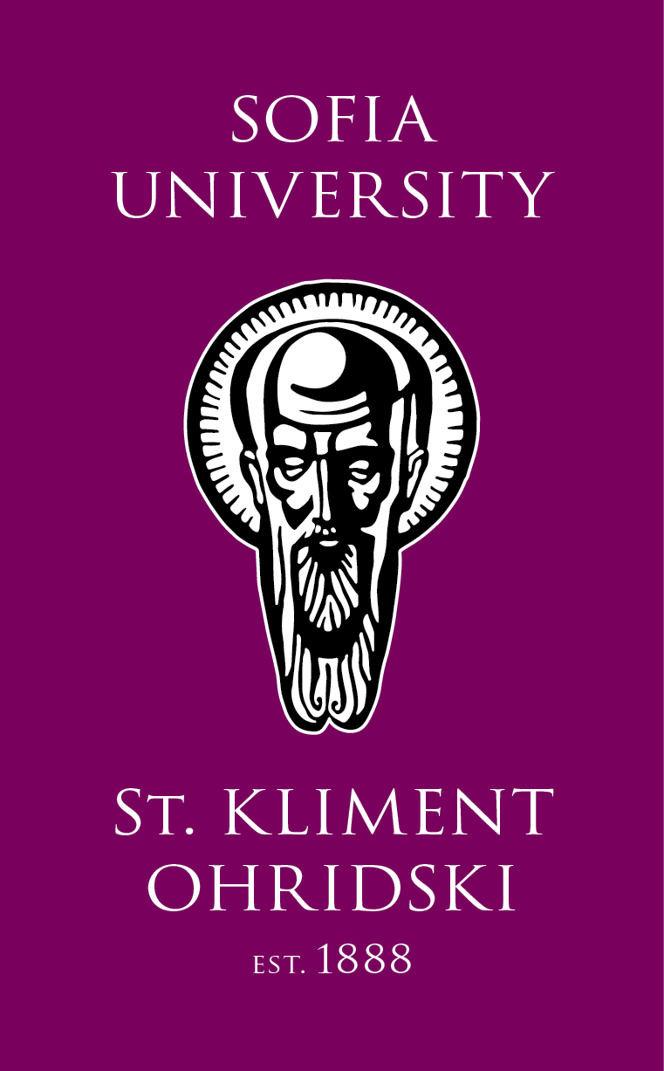
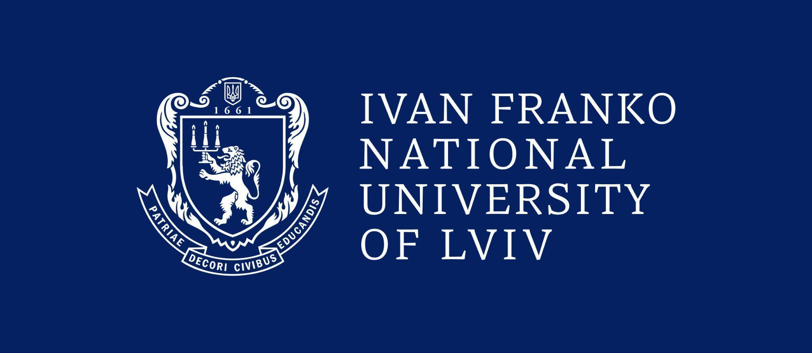
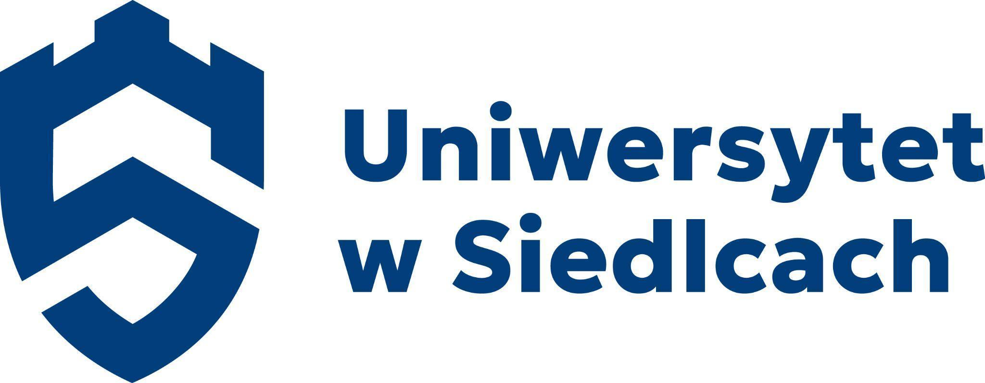
,

Ist INTERNATIONAL SCIENTIFIC CONFERENCE
EDUCATION AND SOCIAL SUPPORT IN THE FACE OF GLOBAL CIVILIZATIONAL CHANGES – CONTEXTS, CHALLENGES,
AND DEVELOPMENT PERSPECTIVES
INCLUSIVE EDUCATION AND SOCIAL TRANSFORMATION

I MIĘDZYNARODOWA KONFERENCJA NAUKOWA
EDUKACJA I WSPARCIE SPOŁECZNE W OBLICZU GLOBALNYCH PRZEMIAN CYWILIZACYJNYCH – KONTEKSTY, WYZWANIA
I PERSPEKTYWY ROZWOJU
EDUKACJA INKLUZYJNA WOBEC TRANSFORMACJI SPOŁECZNEJ

University of Siedlce, Poland
Ivan Franko National University of Lviv, Ukraine
Sofia University “St. Kliment Ohridski”, Bulgaria

February 6th, 2026/ 6 luty 2026

Honorary patronage/Patronaty honorowe:


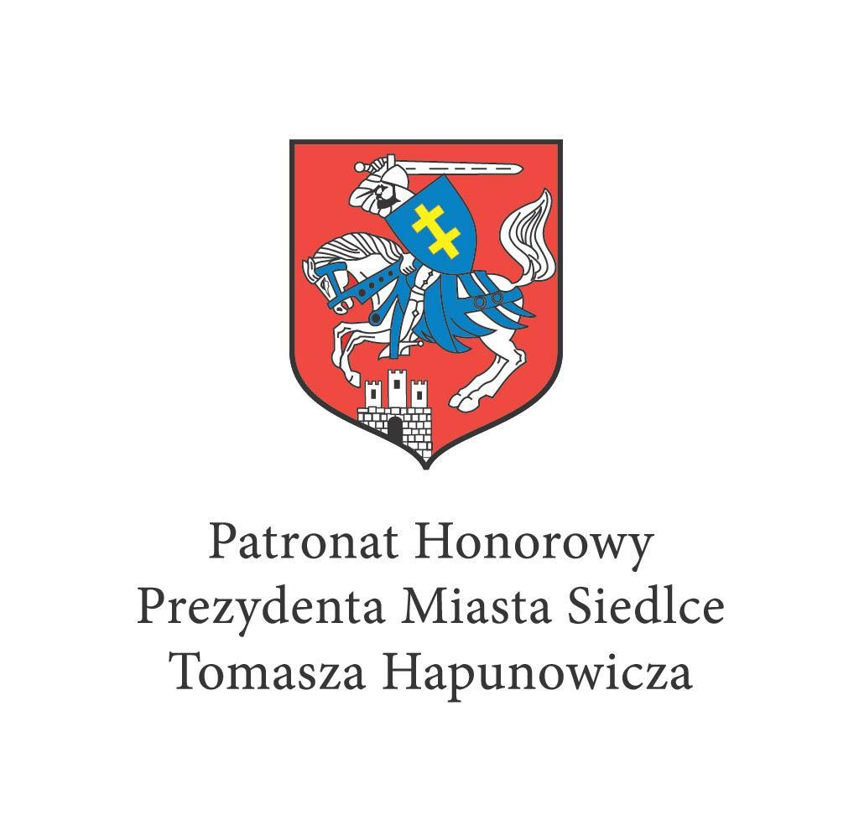
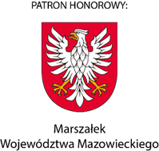
Rektor Uniwersytetu w Siedlcach
SCIENTIFIC COMMITTEE / KOMITET NAUKOWY
dr hab. Janina Florczykiewicz, prof. UwS, Uniwersytet w Siedlcach, Polska
dr hab. Stanisław Topolewski, prof. UwS, Uniwersytet w Siedlcach, Polska
dr hab. Urszula Tyluś, prof. UwS, Uniwersytet w Siedlcach, Polska
dr hab. Hanna Żuraw, prof. UwS, Uniwersytet w Siedlcach, Polska
dr hab. Elżbieta Gaweł-Luty, prof. AMW, Akademia Marynarki Wojennej
Associate Prof. Dmytro Hertsyuk, PhD, Ivan Franko National University of Lviv, Ukraine
Associate Prof. Olha Stoliaryk, PhD, Ivan Franko National University of Lviv, Ukraine
Associate Prof. Victoriya Loboda, PhD, Ivan Franko National University of Lviv, Ukraine
Associate Prof. Iryna Sybashkevych, PhD, Ivan Franko National University of Lviv, Ukraine
Associate Prof. Alla Marchuk, PhD, Ivan Franko National University of Lviv, Ukraine
Associate Prof. Vanya Bozhilova, PhD, Sofia University “St. Kliment Ohridski”, Bulgaria
Associate Prof. Yordanka Nikolova, PhD, Sofia University “St. Kliment Ohridski”, Bulgaria
Ch. Asst. Prof. Daniel Polihronov, PhD, Sofia University “St. Kliment Ohridski”, Bulgaria
dr. hab. Elena Railean, PhD in Science of Education, University of Political and Economic European Studies ‘C. Stere’, Republic of Moldova
Prof. Ioana Roman, University of Agricultural Sciences and Veterinary Medicine, Romania

ORGANIZING COMMITTEE / KOMITET ORGANIZACYJNY
dr hab. Janina Florczykiewicz, prof. UwS, Uniwersytet w Siedlcach, Polska
Dr Agnieszka Dybowska, Dyrektor Centrum Współpracy Międzynarodowej, Uniwersytet w Siedlcach, Polska
dr. hab. Elena Railean, PhD in Science of Education, University of Political and Economic European Studies ‘C. Stere’, Republic of Moldova
dr Agata Fijałkowska-Mroczek, Uniwersytet w Siedlcach, Polska
dr Renata Matysiuk, Uniwersytet w Siedlcach, Polska
dr Katarzyna Skalska, Uniwersytet w Siedlcach, Polska
dr Ewa Wyczółkowska, Uniwersytet w Siedlcach, Polska
dr Sabina Wieruszewska-Duraj, Uniwersytet w Siedlcach, Polska
dr Radosław Korneć, Uniwersytet w Siedlcach, Polska
Associate Prof. Valentina Stets, PhD, Ivan Franko National University of Lviv, Ukraine
Assistant Anastasia Perha, Ivan Franko National University of Lviv, Ukraine
Assistant Khrystyna Borenets, Ivan Franko National University of Lviv, Ukraine
Assistant Olesya Tsymbala, Ivan Franko National University of Lviv, Ukraine
Ch. Asst. Prof. Daniel Polihronov, PhD, Sofia University “St. Kliment Ohridski”, Bulgaria
Ch. Asst. Prof. Daniela Racheva, PhD, Sofia University “St. Kliment Ohridski”, Bulgaria
Ch. Asst. Prof. Veronika Racheva, PhD, Sofia University “St. Kliment Ohridski”, Bulgaria
Ch. Asst. Prof. Teodorina Milusheva, PhD, Sofia University “St. Kliment Ohridski”, Bulgaria
Ch. Asst. Prof. Aleksandar Hristov, PhD, Sofia University “St. Kliment Ohridski”, Bulgaria
mgr Alicja Wydra, Uniwersytet w Siedlcach, Polska
mgr Adam Ługowski, Wydawnictwo Novas Artes, Polska

CONFERENCE PROGRAM / PROGRAM KONFERENCJI
06.02.2026, GOOGLE MEET (ONLINE)

Time zone / Strefa czasowa: Europe/Warsaw
10:00am–2:00pm

Link to video call/Link do rozmowy wideo:
https://meet.google.com/rsw-mjqu-aqd

CEREMONIAL OPENING OF CONFERENCE /
UROCZYSTE OTWARCIE KONFERENCJI
Time zone/Strefa czasowa: Europe/Warsaw
10.00am – 10.30am google meet

Welcoming of participants, speeches by representatives of universities organizing the conference and invited guests/ Powitanie uczestników, przemówienia przedstawicieli uczelni organizujących konferencję i gości konferencji

Director of the Institute of Pedagogy dr hab. Janina Florczykiewicz, University of Siedlce, Poland , Director of the Center for International Cooperation dr Agnieszka Dybowska, University of Siedlce, Poland
Vice-Rector of Career Development, Alumni, Business and Employers’ Networks, Sofia University St. Kliment Ohridski Doctor of Economic Sciences, Prof. Sonya Mileva
Rector of Ivan Franko National University of Lviv, Academician of the National Academy of Sciences of Ukraine, Doctor of Chemical Sciences, Prof. Roman Gladyshevskii
Vice-Rector for Research and Innovation at Ivan Franko National University of Lviv, Doctor of Pedagogical Sciences, Prof. Olena Kvas
Dean of the Faculty of Pedagogical Education at Ivan Franko National University of Lviv, Candidate of Pedagogical Sciences (PhD), Assoc. Prof. Dmytro Hertsyuk
Dean of the Faculty of Education at Sofia University ‘St. Kliment Ohridski’, Bulgaria, Assoc. Prof. Dr. Vanya Bozhilova
Ch. Asst. Prof. Daniel Polihronov, Lecturer in Department Theory of Education, Faculty of Education, Sofia University ‘St. Kliment Ohridski’, Bulgaria

Opening of the conference/ Otwarcie konferencji:
Rector of the University of Siedlce prof. dr hab. Mirosław Minkina

PLENARY SESSION, PART I / SESJA PLENARNA, CZĘŚĆ I
Time zone/Strefa czasowa: Europe/Warsaw
10.30am – 11.50am google meet
https://meet.google.com/rsw-mjqu-aqd

Session Chairs / Przewodniczą:
dr hab. Janina Florczykiewicz prof. UwS, University of Siedlce, Poland
Ch. Asst. Prof. Daniel Polihronov PhD, Sofia University “St. Kliment Ohridski” Bulgaria
Prof. Ioana Roman, University of Agricultural Sciences and Veterinary Medicine, Romania
dr Agnieszka Dybowska,University of Siedlce, Poland

10.30am – 10.50am | Prof. Dr. Sc. Huseyin Kyuchuk, University of Silesia, Katowice, Poland, The Role of Mother Tongue in the Process of Inclusive Education of Roma Children [in English]
10.50am – 11.10am | Assoc. Prof. Dr. Vanya Bozhilova, Sofia University "St. Kliment Ohridski", Bulgaria, The Role of Literacy in Enhancing the Well-being of Adult Learners – in the Context of Inclusive Practices [in English]
11.10 am– 11.30am | Ch. Asst. Prof. Dr. Daniel Polihronov, Sofia University “St. Kliment Ohridski”, Bulgaria, Inclusion as a Social-pedagogical Strategy for the Resocialisation of Persons with Emotional and Behavioural Disorders [in English]
11.30am – 11.50am | Prof. Dr. Hab. in Political Sciences, MSW, Tetyana Semigina, Expert of the League of Social Workers of Ukraine, Ukraine, Keeping the Profession Alive amid War: Rethinking Education and Lifelong Learning in Ukrainian Social Work [in English]

PLENARY SESSION, PART II / SESJA PLENARNA, CZĘŚĆ II
Time zone/Strefa czasowa: Europe/Warsaw
12.20pm – 1.50pm google meet
https://meet.google.com/rsw-mjqu-aqd

Session Chairs / Przewodniczą:
dr hab. Associate Prof. Olha Stoliaryk, PhD, Ivan Franko National University of Lviv, Ukraine
dr hab. Agnieszka Lewicka-Zelent, prof. UMCS, Maria Curie-Skłodowska University in Lublin, Poland
dr Agnieszka Dybowska, University of Siedlce, Poland

12.20pm–  12.40pm | prof. dr hab. Ryszard Bera, University of Siedlce, Poland, Axiology sense of work of generation Z [Aksjologiczny sens pracy pokolenia Z]
12.40pm – 1.00pm | Associate Professor, Candidate of Pedagogical Sciences, Viktoriia Loboda, Ivan Franko National University of Lviv, Ukraine, Design thinking and project-based learning as tools for developing prosocial competencies of students majoring in ‘Social Work and Counseling [in English]
1.00pm – 1.20pm | dr hab. Justyna Kusztal, prof. UJ, Jagiellonian University in Kraków, Poland, Protection of the rights of children with special linguistic needs in juvenile justice [in English]
1.20pm – 1.35pm | dr hab. Bożena Marzec, prof. AH, dr Barbara Grzyb, Humanitas University in Sosnowiec, Poland  Inclusive education in the context of migration, multiculturalism, and social mobility, [Edukacja inkluzyjna w warunkach migracji, wielokulturowości i mobilności społecznej]
1.35pm – 1.50pm | dr hab. Agnieszka Lewicka-Zelent, prof. UMCS, Maria Curie-Skłodowska University in Lublin, Poland  Mediation education towards responsibility, empathy and forgiveness, [Edukacja mediacyjna w kierunku odpowiedzialności, empatii i przebaczenia]

SECTION TOPICS/ OBRADY W SEKCJACH
Time zone/Strefa czasowa: Europe/Warsaw
2.00pm - 5.00pm*

* 3.00pm - 6.00pm [Eastern European Time; UTS+2:00]

https://meet.google.com/juv-geqp-krw
SECTION 1 / SEKCJA 1
Inclusive Education as a Space for Realizing the Ideas of Equality and Agency in a Diverse Society
Edukacja włączająca jako przestrzeń realizacji idei równości i podmiotowości w zróżnicowanym społeczeństwie
Приобщаващото образование като пространство за реализиране на идеите за равенство и активност в многообразно общество
Section Presidium / Prezydium sekcji
Prof. Dr. Sc. Neli Ivanova, Sofia University “St. Kliment Ohridski”, Bulgaria
Prof. Dr. Ginka Mehandzhiyska, Sofia University “St. Kliment Ohridski”, Bulgaria
Assoc. Prof. Dr. Vanya Bozhilova, Sofia University “St. Kliment Ohridski”, Bulgaria
Assoc. Prof. Dr. Evgeniya Topolska, New Bulgarian University, Bulgaria
Section Chairs / Przewodniczą:
Ch. Asst. Prof. Daniel Polihronov, PhD, Sofia University “St. Kliment Ohridski” Bulgaria
2.00 pm – 2.10 pm | Prof. Dr. Sc. Neli Ivanova, Sofia University “St. Kliment Ohridski”, Bulgaria, Religious Tolerance in Adult Literacy Education as a Means of Inclusive Education [in Bulgarian]
2.10 pm – 2.20 pm | Prof. Tetiana Khvalyboha, DSc in Pedagogy, I. Horbachevsky Ternopil National Medical University, Faculty of Medicine, Ukraine. Inclusive approaches in South Korean higher education within the context of global educational transformations [in English]
2.20 pm – 2.30 pm | Prof. Dr. Ginka Mehandzhiyska, Sofia University “St. Kliment Ohridski”, Bulgaria, Social Inclusion and Maintaining Connections in the Local Community among Older Adult in Residential Care Settings [in Bulgarian]
2.30 pm – 2.40 pm | Assoc. Prof. Volodymyr Khomenko, Assoc. Prof. Oleksandr Pashchenko, Assoc. Prof. Yevhenii Koroviaka, Dnipro University of Technology, Ukraine, Realizing Student Agency through Inclusive Teaching Methods in Engineering Disciplines within a Diverse Academic Environment [in English]
2.40 pm – 2.50 pm | Assoc. Prof. Dr. Evgeniya Topolska, New Bulgarian University, Bulgaria, Constructivism in Inclusive Education [in Bulgarian]
2.50 pm – 3.00 pm | Assoc. Prof. Dr. Svetlana Angelova, New Bulgarian University, Bulgaria, Self-Regulated Learning in Elementary Science Education: Its Role in the Inclusion of Students with Behavioral Disorders [in Bulgarian]
3.00 pm – 3.10 pm | Assoc. Prof. Dr. Diyana Dimitrova, University of Veliko Tarnovo “St. Cyril and Methodius”, Bulgaria, In Seeking the New Face of the Partnership between a University and the School for Teacher Training in the Context of Inclusive Education [in Bulgarian]
3.10 pm – 3.20 pm | Assoc. Prof. Dr. Katya Getova, Sofia University “St. Kliment Ohridski”, Bulgaria, Inclusion of Gifted Children in the Pedagogical and Social Space [in Bulgarian]
3.20 pm – 3.30 pm | COFFEE BREAK
3.30 pm – 3.40 pm | Ch. Asst. Prof. Dr. Daniela Racheva, Sofia University “St. Kliment Ohridski”, Bulgaria, Art and Creative Activities in Support of Social Inclusion and Inclusive Education [in Bulgarian]
3.40 pm – 3.50 pm | Ch. Asst. Prof. Dr. Desislava Stoeva, Sofia University “St. Kliment Ohridski”, Bulgaria, Socio‑Pedagogical Strategies and Practices for Developing Social Competence in Preschool Children [in English]
3.50 pm – 4.00 pm | Ch. Asst. Prof. Dr. Radeya Gesheva, Sofia University “St. Kliment Ohridski”, Bulgaria, Teaching Literature as a Tool for Prosocial Behaviour [in Bulgarian]
4.00 pm – 4.10 pm | Ch. Asst. Prof. Dr. Teodora Valeva, Burgas State University “Prof. Dr. Assen Zlatarov”, Bulgaria, Specifics and Characteristics of Children's Literature as an Inclusive Cultural and Pedagogical Space [in Bulgarian]
4.10 pm – 4.20 pm | Ch. Asst. Prof. Dr. Avi Abner, Burgas State University “Prof. Dr. Assen Zlatarov”, Bulgaria, The Education Role of Parent under Conditions of Inclusive Education [in Bulgarian]
4.20 pm – 4.30 pm | Dr. Rumyana Neshkova, ‘Nicola Ikonomov’ Primary School, Bulgaria, Social and Emotional Learning Through Project-based Activities in a Multicultural Environment [in Bulgarian]
4.30 pm – 4.40 pm | Dr. Irena Raykova-Panteleeva, 137 Secondary School “Angel Kanchev”, Bulgaria, The Role of Etwinning in Building a Culture of Inclusion [in English/Bulgarian]
4.40 pm – 4.50 pm | Phd Student Desislava Krasteva, Sofia University “St. Kliment Ohridski”, Bulgaria, The Role of the Mother Figure in Bulgarian Children's Literature: from Folk Tales to Contemporary Texts [in Bulgarian]

SECTION 2 / SEKCJA 2
Contemporary contexts of education and social support in the face of civilizational, technological and cultural changes
Współczesne konteksty edukacji i wsparcia społecznego w obliczu przemian cywilizacyjnych, technologicznych i kulturowych
Section Presidium / Prezydium sekcji
dr hab. Urszula Tyluś, prof. UwS, University of Siedlce, Poland;
dr hab. Hanna Żuraw, prof. UwS, University of Siedlce, Poland

Panel 1
Inkluzja, równość i prawa dziecka w zróżnicowanych społeczeństwach
Inclusion, equality and children's rights in diverse societies

Panel Chairs / Przewodniczą:
dr hab. Zamkowska Anna, prof. URad, Casimir Pulaski Radom University, Poland
dr hab. Tamara Zacharuk, prof. UwS, prof. UwS, Dr hab. Sławomir Sobczak, prof. UwS, University of Siedlce, Poland
dr hab. Sławomir Sobczak, prof. UwS, prof. UwS, Dr hab. Sławomir Sobczak, prof. UwS, University of Siedlce, Poland

Link to video call/Link do rozmowy wideo:
https://meet.google.com/zux-mmra-wxc\

2.00pm – 2.15pm | dr hab. Anna Zamkowska, prof. URad, dr Monika Koczańska, Casimir Pulaski Radom University, Poland  “Scaffolding” as a strategy for educating children with special educational needs in an inclusive preschool class a systematic review of research, [„Budowanie rusztowania” jako strategia edukacji dzieci ze specjalnymi potrzebami edukacyjnymi w inkluzyjnym oddziale przedszkolnym – systematyczny przegląd badań]
2.15pm – 2.30pm | dr Joanna Leśniak, University of Rzeszów, Poland  Inclusive Education – the role of teachers and specialists in working with students, [Edukacja włączająca – rola nauczycieli i specjalistów w pracy z uczniem]
2.30pm – 2.45pm | dr hab. Tamara Zacharuk, prof. UwS, dr hab. Sławomir Sobczak, prof. UwS, University of Siedlce, Poland  Presence as a Condition of the Social Rehabilitation, [Obecność jako warunek resocjalizacji ]
2.45pm – 3.00pm | dr Małgorzata Wiśniewska, University of Siedlce, Poland  Social support for the child with SEN and family at school - possibilities and limitations, [Wsparcie społeczne dziecka ze SPE i jego rodziny w szkole – możliwości i ograniczenia]
3.00pm– 3.15pm | dr Radosława Kompowska-Marek, dr Aleksandra Plaskota, The Maria Grzegorzewska University  Adult Development in Times of Contemporary Change: Findings from a Study of Postgraduate Art Therapy Students, [Rozwój osób dorosłych w warunkach współczesnych przemian – perspektywa arteterapii]
3.15pm – 3.30pm | mgr Agnieszka Szymani, MSCDN Siedlce, Poland  "Meetings with music" - group musical activity of children and adolescents with Down syndrome and their neurotypical peers”, [“Spotkania z muzyką” – zespołowa aktywność muzyczna dzieci i młodzieży z zespołem Downa oraz ich rówieśników neurotypowych]
3.35pm – 3.50pm | dr Renata Matysiuk, University of Siedlce, Poland  The right to education and inclusive education – pedagogical and social implications of equality and non-discrimination, [Prawo do edukacji a edukacja inkluzyjna – pedagogiczne i społeczne implikacje równości i niedyskryminacji]
3.50pm – 4.00pm | dr Sabina Wieruszewska-Duraj, University of Siedlce, Poland  Improving the quality of educational and support activities based on the universal design model and accessibility in working with people with special needs, [Projektowanie uniwersalne i dostępność w realizacji idei równości i podmiotowości w edukacji dzieci]
4.00pm – 4.15pm | Associate Professor Iryna Buzenko, Candidate of Pedagogical Sciences, Teacher, Vinnytsia Humanities and Pedagogical College, Vinnytsia, Ukraine, Associate Professor Iryna Zelenenka, Candidate of Philological Sciences, Vinnytsia State Pedagogical University named after Mykhailo Kotsyubynskyi, Vinnytsia, Ukraine,  Eco-aesthetic potential and valeological culture of learners in Ukraine
4.15pm – 4.30pm | dr Katarzyna Skalska, University of Siedlce, Poland,  Inclusive education and the need for new educational and pedagogical content, [Edukacja włączająca a potrzeba nowych treści wychowawczych i edukacyjnych]
4.30pm –  4.45pm | dr Ewa Jówko, University of Siedlce, Poland,  Kultura szkoły jako przestrzeń dialogu i inkluzji – różnorodność jako zasób, nie wyzwanie, [School culture as a space for dialogue and inclusion – diversity as a resource, not a challenge]
4.45pm –  5.00pm | dr Małgorzata Myszka-Bujno, University of Siedlce, Poland,  Wspieranie poczucia własnej wartości w edukacji i wychowaniu, [Supporting self-esteem in education and upbringing]

Panel 2

Contemporary challenges of supporting the development and protection of the individual
Współczesne wyzwania wsparcia rozwoju i ochrony jednostki

Panel Chairs / Przewodniczą:
dr hab. Elżbieta Gaweł-Luty, prof. AMW, Naval Academy, Poland
dr hab. Hanna Żuraw, prof. UwS, University of Siedlce, Poland

Link to video call/Link do rozmowy wideo:
https://meet.google.com/ebf-usjs-vog

2.00pm – 2.15pm | dr hab. Żuraw Hanna, prof. UwS, University of Siedlce, Poland  Risk society, the future as a mystery, dilemmas and questions [Ku przyszłości. Nowe paradygmaty edukacji i wsparcia społecznego]
2.15pm – 2.30pm | prof. Anna Zhukova, PhD in Educational and Pedagogical Sciences, Department of Foreign Languages, Hetman Petro Sahaidachnyi National Ground Forces Academy, Lviv, Ukraine, Transformation of the professional role of a foreign language teacher in the context of 21st-century civilizational and technological challenges
2.30pm – 2.45pm | Foreign Language Teacher Mykhaylo Cherneha, Separate Structural Unit “Boyarka Professional College of the National University of Life and Environmental Sciences of Ukraine”, Ukraine,  Inclusive education in the context of technological change: new approaches to social support for learners
2.45pm – 3.00pm | dr hab. Gaweł-Luty Elżbieta, prof. AMW, Naval Academy, Poland  Intercultural education In the face of social differences, [Edukacja międzykulturowa wobec różnic społecznych]
3.00pm– 3.15pm | dr Artur Dąbek, State University of Applied Sciences in Koszalin, Poland  Contemporary needs for inclusive action in the field of civil protection, [Współczesne potrzeby działania inkluzywnego w zakresie ochrony ludności]
3.15pm – 3.30pm | dr Ewa Jegier, Akademia Wymiaru Sprawiedliwości, Poland  Psychological Development of Children and Adolescents in the Context of Contemporary Social and Civilizational Changes, [Rozwój psychiczny dzieci i młodzieży w kontekście współczesnych zmian społecznych i cywilizacyjnych]
3.35pm – 3.50pm | dr Justyna Sala-Suszyńska, Maria Curie-Skłodowska University in Lublin, Poland  Bilingualism – perspectives and difficulties in working with students, [Bilingualism – perspektywy i trudności w pracy z uczniem]
3.50pm – 4.00pm | dr Ruslan Yakovyshyn, Pedagogium Wyższa Szkoła Nauk Społecznych w Warszawie, Poland  Prevention of addiction among teenagers in contemporary contexts of exclusion and social support, [Profilaktyka nałogów wśród nastolatków we współczesnych kontekstach wykluczenia i wsparcia społecznego]
4.00pm – 4.15pm | mgr Alicja Wiaduch, Naval Academy, Poland  The Study of Caregiving Practices Inspired by TBRI® in Foster Care: A Relational Pedagogy Perspective, [Badanie praktyk opiekuńczych inspirowanych TBRI® w pieczy zastępczej – perspektywa pedagogiki relacyjnej]
4.15pm – 4.30pm | mgr Gabriela Żaboklicka, absolwent, VIZJA University, Poland  Retrospective Assessment of Parental Marital Quality and Children’s Preferences for Relationship Form, [Retrospektywna ocena jakości małżeństwa rodziców a preferencje w zakresie formy związku]
4.30pm – 4.45pm | Małgorzata Kulawska, student, University of Siedlce, Poland  The role of education and support in helping victims of pedophilia and grooming, [Rola edukacji i wsparcia w procesie pomocy ofiarom pedofilii i groomingu]

Panel 3
Education towards the virtualization of life and values
Edukacja wobec wirtualizacji życia i wartości

Panel Chairs / Przewodniczą:
dr hab. Grzegorz Grzybek, University of Rzeszów, Poland;
dr Agata Jacewicz, The Podlasie Academy in Białystok, Poland
dr Ewa Trojanowska, Maria Curie-Skłodowska University in Lublin, Poland

Link to video call/Link do rozmowy wideo:
https://meet.google.com/xtd-roxr-usv

2.00pm – 2.15pm | mgr Artur Banaszak, WSGE University of Applied Sciences Józefów, Poland  Christian Pedagogy in the Face of Digital Dehumanization – Educating for Relationality and Empathy, [Pedagogika chrześcijańska wobec cyfrowej dehumanizacji – wychowanie do relacyjności i empatii]
2.15pm – 2.30pm | dr hab. Janina Florczykiewicz, prof. UwS, University of Siedlce, Poland  Reality "at a distance" - socio-emotional consequences of immersion in the digital world, [Rzeczywistość „w dystansie” – społeczno-emocjonalne konsekwencje zanurzenia w świecie cyfrowym]
2.30pm – 2.45pm | dr Ewelina Majewska-Pyrkosz, Humanitas University in Sosnowiec, Poland  Artificial intelligence in inclusive education from the perspective of sustainable development, [Sztuczna inteligencja w edukacji inkluzyjnej w perspektywie zrównoważonego rozwoju. Edukacja w erze cyfrowej]
2.45pm – 3.00pm | dr hab. Grzegorz Grzybek, University of Rzeszów, Poland  Sex Education: Between Education and Moralization,  [Edukacja seksualna: między wychowaniem a moralizowaniem]
3.00pm– 3.15pm | dr Ewa Trojanowska, Maria Curie-Skłodowska University in Lublin, Poland  Students' sense of efficacy and empathy, [Poczucie skuteczności i empatia studentów kierunków pedagogicznych]
3.15pm – 3.30pm | dr Izabela Ziębacz, Jan Dlugosz University in Czestochowa, Poland  Social competencies as regulatory mechanisms of the individual in the information environment – a reinterpretation of international data from a systemic perspective, [Kompetencje społeczne jako mechanizmy regulacyjne – reinterpretacja w świetle raportów międzynarodowych]
3.35pm – 3.50pm | dr Agata Jacewicz, The Podlasie Academy in Białystok, Poland  STEAM as a new approach to preschool education in 21st-century, [STEAM jako nowe podejście do nauczania w przedszkolu XXI wieku]
3.50pm – 4.00pm | dr Marzena Lisowska, Mgr Katarzyna Drabarek, University of Siedlce/ MSCDN, Poland  Technologies that connect – eTwinning projects as a space for shaping pro-social competencies and global awareness from the perspective of teacher training and foreign language learners, [Technologie, które łączą – projekty eTwinning jako przestrzeń kształtowania kompetencji prospołecznych]
4.00pm – 4.15pm | mgr Alicja Wydra, University of Siedlce, Poland  The project method in the perspective of Montessori pedagogy and the assumptions of neurodidactics, [Metoda projektu w perspektywie pedagogiki Montessori i założeń neurodydaktyki]
4.15pm – 4.30pm | Natalia Czekała, Martyna Galubińska, students, Naval Academy, Poland  Media Education Among Pedagogy Students – Diagnosis of Attitudes and Knowledge, [Edukacja medialna wśród studentów pedagogiki – diagnoza postaw i wiedzy]

Panel 4
Education in the face of developmental and cultural challenges of today
Edukacja wobec rozwojowych i kulturowych wyzwań współczesności

Panel Chairs / Przewodniczą:
dr hab. Urszula Tyluś, prof. UwS, dr hab. Urszula Oszwa UMCS

Link to video call/Link do rozmowy wideo:
https://meet.google.com/rsw-mjqu-aqd

2.00pm – 2.15pm | dr hab. Urszula Oszwa, Maria Curie-Skłodowska University in Lublin, Poland  Resilience and well-being of future primary school teachers - peer support programme, [Rezyliencja i dobrostan przyszłych nauczycielek edukacji elementarnej – program wsparcia rówieśniczego]
2.15pm – 2.30pm | dr Ewa Wyczółkowska, University of Siedlce, Poland  Goals, attitudes and perceived benefits as predictors of cooperation between preschool teachers and the educational environment, [Cele, postawy i postrzegane korzyści jako predyktory współpracy nauczycieli przedszkoli ze środowiskiem wychowawczym]
2.30pm – 2.45pm | dr Maryna Saltykova-Vaukovich, University of Siedlce, Poland Methodological features of applying Milton Erickson's fairy tale therapy in social support for children, [Bajkoterapia Miltona Eriksona w społecznym wsparciu dzieci]
2.45pm – 3.00pm | dr Monika Lewicka, Kazimierz Wielki University, Poland  Motherhood in the era of civilizational transformation – educational challenges and the need for social support, [Macierzyństwo w epoce przemian cywilizacyjnych – wyzwania edukacyjne i potrzeby wsparcia społecznego]
3.00pm– 3.15pm | dr Agata Fijałkowska-Mroczek, Patrycja Flisiuk, student, University of Siedlce, Poland  Volunteering in kindergarten - a bridge between theory and pedagogical practice, [Wolontariat w przedszkolu - most między teorią, a praktyką pedagogiczną]
3.15pm – 3.30pm | dr Agata Fijałkowska- Mroczek, Jakub Materka, student, University of Siedlce, Poland  „“Who Are You? A Little Pole!” – How to Build Patriotic Values in Children in the Age of Globalization, [Kto ty jesteś? Polak mały!” – wychowanie patriotyczne w dobie globalizacji]
3.35pm – 3.50pm | dr hab. Urszula Tyluś, prof. UwS, University of Siedlce, Poland Self-education in Early Childhood Education in the Context of Civilizational and Technological Changes from Teachers’ Perspectives, [Samowychowanie w edukacji wczesnoszkolnej wobec przemian cywilizacyjnych]
3.50pm – 4.00pm | mgr Krzysztof Jurek, Jagiellonian University in Kraków, Poland  Participatory management through organisational listening as a new tool for civic education, [Zarządzanie partycypacyjne poprzez słuchanie organizacyjne jako narzędzie edukacji obywatelskiej]

SECTION 3 / SEKCJA 3
Education in response to the need to develop prosocial competencies and global awareness
Edukacja wobec potrzeby rozwijania kompetencji prospołecznych i świadomości globalnej
Educația în contextul necesității dezvoltării competențelor prosociale și a conștiinței globale
Section Chairs / Przewodniczą:
Elena Railean, Dr. Hab., PhD in Science of Education, University of Political and Economic European Studies C. Stere & Ion Creangă Pedagogical State University of Chisinau, Republic of Moldova,
dr Ewa Wyczółkowska University of Siedlce, Poland

Link to video call / Link do rozmowy wideo:
https://meet.google.com/whc-asgg-eom
2.00pm – 2.15pm | Asst. Prof. Pramila Ramani, PhD, Central University of Tamil Nadu, India,  Cultural Transformations and Education: An Indian Perspective
2.15pm – 2.30pm | Assoc. Prof. Inna Kovalchuk, Yurii Fedkovych Chernivtsi National University, Ukraine  Developing prosocial competencies and global awareness of higher education students through geography education
2.30pm – 2.45pm | Laurențiu Constantinescu, PhD, Private Institute for Scientific, Humanistic and Technological Research, Romania  Analysis of the legal basis for incriminating the crime of violating public order and peace
2.45pm – 3.00pm | Bianca-Patricia Mureșan, Scientific Researcher at Tampere University, Republic of Finland  Aspecte definitorii privind repararea daunelor cauzate regnului animal și protecția acestuia
3.00pm– 3.15pm | Elena-Casiana Alexăndrescu, Scientific Researcher, Tampere University, Republic of Finland  Conceptual Benchmarks on Damage Caused to Wildlife as a Result of Sport and Recreational Hunting
3.15pm – 3.30pm | PhD Student Mykola Myroshnychenko, H.S. Skovoroda Kharkiv National Pedagogical University, Kharkov, Ukraina  Student orchestra of folk instruments as a space for inclusive and prosocial arts education
3.30pm – 3.45pm | Senior Researcher, PhD student, Laura-Maria Giană, University of Naples ,,Federico II”, Italy  The use, application and utilization of the polygraph technique in the analysis of simulated behavior from a tactical-forensic perspective

SECTION 4 / SEKCJA 4

Bridging Theory and Practice in Education and Social Work: Global Perspectives for Welfare, Justice and Sustainable Futures

Łączenie teorii i praktyki w edukacji i pracy socjalnej: globalne perspektywy dobrobytu, sprawiedliwości i zrównoważonej przyszłości

Поєднання теорії та практики в освіті та соціальній роботі: глобальні перспективи добробуту, справедливості та сталого майбутнього.

Link to video call / Link do rozmowy wideo:
meet.google.com/xei-ynug-qkj
Section Presidium / Prezydium sekcji
Associate Prof. Olha Stoliaryk, PhD, Ivan Franko National University of Lviv, Ukraine
Associate Prof. Viktoriya Loboda, PhD, Ivan Franko National University of Lviv, Ukraine

Panel 1
Inclusive Education and Social Work in the Context of Contemporary Social and Global Transformations

Panel Chairs / Przewodniczą:
Associate Prof. Olha Stoliaryk, PhD, Ivan Franko National University of Lviv, Ukraine

2.00pm-  2.10 pm | Assoc. Prof. Dr. Zoriana Matsiuk, Lesya Ukrainka Volyn National University, Ukraine  PhD Student Yurii Symchukevych, Lesya Ukrainka Volyn National University, Ukraine  National accessibility strategies as a factor in the development of inclusive education and social work
2.10pm-  2.20 pm | Assoc. Prof. Svitlana Onyshchuk, Odesa Academy of Continuing Education, Ukraine  Social-emotional learning of students with special educational needs in physical education classes
2.20pm-  2.30 pm | Prof. Mariia Diachenko, Classical Private University, Ukraine  Features of Social and Educational Work in the Contemporary Context of Inclusive Education
2.30pm-  2.40 pm | Prof. Nataliia Machynska, Ivan Franko National University of Lviv, Ukraine  Adult education: contemporary dimension
2.40pm-  2.50 pm | Assoc. Prof. Oksana Muzychenko-Kozlovska, Lviv Polytechnic National University, Ukraine  Eco-oriented education as a foundation for modernising regional environmental policy within the context of Ukraine’s social transformation
2.50pm-  3.00 pm | Prof. Oksana Kravchenko, Pavlo Tychyna Uman State Pedagogical University, Ukraine  PhD Student Andrii Dzyhovskyi, Pavlo Tychyna Uman State Pedagogical University, Ukraine  Model of Readiness of Future Social Workers for Organizing Project Activities
3.00pm-  3.10pm | Prof. Svitlana Cherneta, Lesya Ukrainka Volyn National University, Ukraine  Raising children in a family environment as a priority direction of state policy
3.10pm-  3.20 pm | Assoc. Prof. Olena Honcharenko, Sumy State Pedagogical University, Ukraine  Assoc. Prof. Iryna Ionova, Sumy State Pedagogical University, Ukraine  Preventing professional burnout of social service managers
3.20pm-  3.30 pm | Assoc. Prof. Nataliia Svynarenko, John Paul II Catholic University of Lublin, Poland  Cultural and educational activities of charitable organizations in Poland as a means of supporting Ukrainian military refugees (2022-2026)
3.30pm-  3.40 pm | Assoc. Prof. Olha Maltseva, Priazovskyi State Technical University, Ukraine  Transformational Potential of Education in the Context of Global Migration Processes: Cultural Adaptation and Social Integration
3.40pm-  3.50 pm | Assistant Anastasiia Perha, Ivan Franko National University of Lviv, Ukraine  Assistant Khrystyna Borynets, Ivan Franko National University of Lviv, Ukraine  Supervision and professional development of social workers as tools for ensuring social justice and sustainable well-being

Panel 2
Educational Environment, Well-being, and Social Integration: Interdisciplinary Approaches and Practical Solutions
Panel Chairs / Przewodniczą:
Associate Prof. Viktoriya Loboda, PhD, Ivan Franko National University of Lviv, Ukraine
2.00pm-  2.10 pm | Assoc. Prof. Liudmyla Tokaruk, Taras Shevchenko National University of Kyiv, Ukraine  Social-pedagogical counseling of higher education students through teamwork
2.10pm-  2.20 pm | Assoc. Prof. Lesia Volnova, Mykhailo Dragomanov State University of Ukraine, Ukraine  Mental well-being of students as a factor in sustainable development of the educational environment
2.20pm-  2.30 pm | Assoc. Prof. Liubov Nos, Ivan Franko National University of Lviv, Ukraine  University educational space as an environment for developing prosocial competencies and global awareness of students
2.30pm-  2.40 pm | Assoc. Prof. Olha Stoliaryk, Ivan Franko National University of Lviv, Ukraine  Community resilience as a mechanism of adaptation to extreme conditions: transforming social work in Ukraine
2.40pm-  2.50 pm | Methodologist Iryna Steheran, Odesa Academy of Continuing Education, Ukraine  Drama Therapy Resources in the Development of Children with Special Educational Needs
2.50pm-  3.00 pm | Assoc. Prof. Tetiana Martyniuk, Lesya Ukrainka Volyn National University, Ukraine  Social integration of youth with disabilities: theoretical foundations and practical mechanisms
3.00pm-  3.10 pm | Assoc. Prof. Liudmyla Ternova, Cherkasy State Technological University, Ukraine  Social investments in inclusive education: practice and societal impact
3.10pm-  3.20 pm | Assoc. Prof. Oksana Tepla, National University of Life and Environmental Sciences of Ukraine, Ukraine  Intercultural communication in the context of cultural globalisation
3.20pm-  3.30 pm | Assoc. Prof. Hanna Lopatina, Berdyansk State Pedagogical University, Ukraine  Support of persons with special educational needs in the context of inclusive vocational education
3.30pm-  3.40pm | Acad. Lina Makhotkina, National University “Chernihiv Collegium”, Ukraine  Changes in the system of social welfare in Ukraine in 2026
3.40pm-  3.50 pm | Practical Psychologist Vitalii Yarmolenko, Kuniv Lyceum of Pluzhenska Village Council, Ukraine  Contemporary contexts of education and social support in the face of civilizational, technological, and cultural changes
3.50pm-  4.00 pm | Assoc. Prof. Sergiy Sydoriv, Vasyl Stefanyk Carpathian National University, Ukraine  Educational and Social Projects as a Catalyst for Professional Motivation and Inclusive Culture of Future Educators in a Sustainable and Decolonised Educational Space

Panel 3
Social Services, Psychosocial Support, and Inclusion in the Context of War and Sustainable Community Development
Panel Chairs / Przewodniczą:
Associate Prof. Iryna Sybashkevych, PhD, Ivan Franko National University of Lviv, Ukraine
2.00pm-  2.10 pm | Prof. Oleh Lisovets, Mykola Hohol Nizhyn State University, Ukraine  The impact of decentralization on the organization of social services in Ukraine
2.10pm-  2.20 pm | Assoc. Prof. Iryna Bychuk, Lesya Ukrainka Volyn National University, Ukraine  The Role of Intersectoral Interaction in Social Case Management of Clients in the Context of Sustainable Community Development
2.20pm-  2.30 pm | Assoc. Prof. Olena Belkina-Kovalchuk, Lesya Ukrainka Volyn National University, Ukraine  Psychosocial Support of the Population as a Component of Social Rehabilitation
2.30pm-  2.40 pm | Assoc. Prof. Victoria Petruk, Lesya Ukrainka Volyn National University, Ukraine  Bridging theory and practice in education and social work: global perspectives for welfare, justice, and sustainable futures – Social adaptation of children affected by war
2.40pm-  2.50 pm | Assoc. Prof. Dmytro Khvalyboha, I. Horbachevsky Ternopil National Medical University, Ukraine  Simulation-based learning as a tool of inclusive pedagogy in contemporary medical education
2.50pm-  3.00 pm | Assoc. Prof. Zoriana Matsiuk, Lesya Ukrainka Volyn National University, Ukraine  PhD Student Oleksandr Volin, Lesya Ukrainka Volyn National University, Ukraine  Social inclusion for individuals with special educational needs: European benchmarks and Ukraine’s development strategy
3.00pm-  3.10 pm | Assoc. Prof. Valentyna Stets, Ivan Franko National University of Lviv, Ukraine  Combining theoretical foundations of inclusion and social work practice with children with disabilities in the context of contemporary social challenges
3.10pm-  3.20 pm | Assoc. Prof. Iryna Subashkevych, Ivan Franko National University of Lviv, Ukraine  Socio-psychological rehabilitation in social work education: responses to contemporary challenges of well-being and social justice
3.20pm-  3.30 pm | Lecturer Iryna Nokhrina, Borys Grinchenko Kyiv Metropolitan University, Ukraine  Prevention of Emotional Burnout of Social Workers Using the Multimodal BASIC PH Model
3.30pm-  3.40 pm | Assistant Olesia Tsymbala, Ivan Franko National University of Lviv, Ukraine  Support groups as a form of psychosocial assistance for mothers of deceased servicemen
3.40pm-  3.50 pm | Lecturer Tetiana Fedchyshyna, Vinnytsia Humanitarian and Pedagogical College, Ukraine  Preschool Education as the Foundation of a Sustainable Future: Integrating Educational and Social Support Practices

Panel 4
Social Justice, Human Rights, and Sustainable Development: Integrating Education and Social Work
Panel Chairs / Przewodniczą:
Associate Prof. Alla Marchuk, PhD, Ivan Franko National University of Lviv, Ukraine
2.00pm-  2.10 pm | Prof. Alla Ryzhanova, Sumy State Pedagogical University, Ukraine  Prof. Nataliia Maksymovska, Sumy State Pedagogical University, Ukraine  Social sustainability as the basis of global sustainable future: project approach to spreading European experience of social work in Ukraine
2.10pm-  2.20 pm | Assoc. Prof. Oleksii Klochko, Sumy State Pedagogical University, Ukraine  Representation of clients’ rights and interests in the social assistance system
2.20pm-  2.30 pm | Assoc. Prof. Alla Marchuk, Ivan Franko National University of Lviv, Ukraine  Assoc. Prof. Nataliia Kalka, Lviv State University of Internal Affairs, Ukraine  Existential dimensions of students’ attitudes toward life during the war: a socio-psychological perspective
2.30pm-  2.40 pm | PhD Student Yurii Klonovskyi, Chernivtsi Yurii Fedkovych National University, Ukraine  Educational and guardianship activities of Theodor Zeckler as a historical model of combining theory and practice in education and social work
2.40pm-  2.50 pm | Acad. Oleksii Znobei, Sumy State Pedagogical University, Ukraine  Transformation of the legal framework of social protection of the population under martial law in Ukraine
2.50pm-  3.00 pm | Assoc. Prof. Oleksandr Malyhin, Ukrainian State University named after Mykhailo Drahomanov, Ukraine  Self-regulation of sexual behavior as a cognitive-behavioral determinant of healthy sexuality
3.00pm-  3.10 pm | Assoc. Prof. Lesia Martirosian, Ivan Franko National University of Lviv, Ukraine  From segregation to inclusion: historical transformation of inclusive education in the dimension of social justice (European experience and Ukrainian context)
3.10pm-  3.20 pm | Master Viktoriia Korol-Kosmyna, Ternopil School No. 3, Ukraine  Inclusive competence of the French language teacher in senior specialized school
3.20pm-  3.30 pm | Assistant Ivanna Sukhotska, Ivan Franko National University of Lviv, Ukraine  Inclusive education and social support system: combining educational practice and social work for a sustainable future
3.30pm-  3.40 pm | Master Marina Nikitina, Kyiv Vocational College of Construction and Municipal Economy, Ukraine  Education and social support in the context of global civilizational transformations: bridging theory and practice
3.40pm-  3.50 pm | Assoc. Prof. Sikorska Lesia Borysivna, Ivan Franko National University of Lviv, Ukraine  Social Worker Benko Oleksandra Petrivna, Municipal Institution of the Lviv Regional Council “Hrushkiv Psychoneurological Residential Care Home”, Ukraine  Work Adaptation Instructor Tripnyk Lidiia Yakivna, Municipal Institution of the Lviv Regional Council “Hrushkiv Psychoneurological Residential Care Home”, Ukraine  From Institutional Care to Supported Living: How Social Work in a Psychoneurological Residential Care Home Catalyzes Inclusive Community Transformation

Podsumowanie konferencji
4.15pm - 5.00pm google meet (online)

Time zone/Strefa czasowa: Europe/Warsaw
Link to video call/Link do rozmowy wideo:
https://meet.google.com/rsw-mjqu-aqd

Prof. Ioana Roman, University of Agricultural Sciences and Veterinary Medicine, Romania
Ch. Asst. Prof. Daniel Polihronov, PhD Sofia University ‘St. Kliment Ohridski’, Bulgaria
dr hab. Gaweł-Luty Elżbieta, prof. AMW, Naval Academy, Poland
Associate Professor Olha Stoliaryk, PhD, Ivan Franko National University of Lviv
dr. hab. Elena Railean, PhD in Science, University of Political and Economic European Studies ‘C. Stere’, Republic of Moldova
dr hab. Janina Florczykiewicz, prof. UwS, Director of the Institute of Pedagogy, University of Siedlce

Scientific Committee

